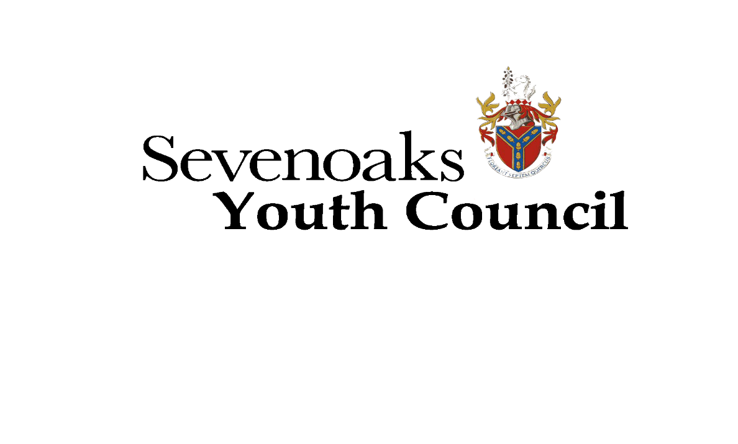

**PRESS RELEASE**

**Make Sevenoaks a better town for young people!**

**Young people between 11 and 18 years old are invited to become a Sevenoaks Youth Councillor.**

The next two-year term of the Sevenoaks Youth Council starts 7th November 2018.

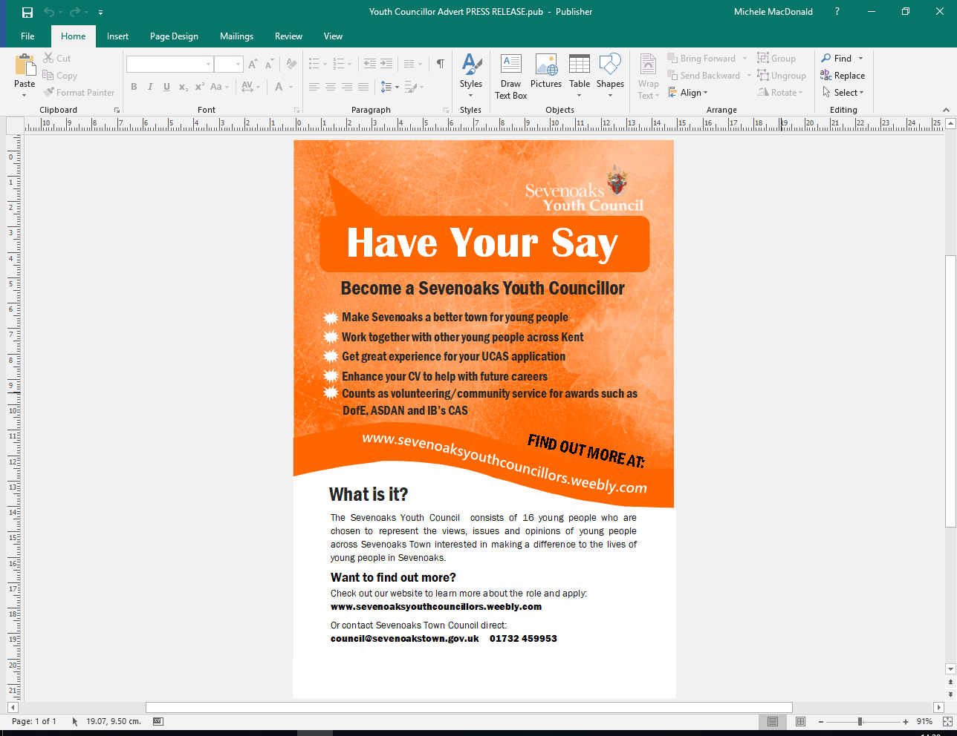

We have spaces for:

* 16 Youth Councillors, aged between 11 and 18, going to school or living in or within 5 miles of Sevenoaks wanting to get things done for the youth of Sevenoaks
* each senior school in Sevenoaks to send representatives from their school. Each school will have one voting right in addition to the Youth Councillors to ensure local young people of all backgrounds are represented.

Should more than 16 young people apply by Friday 5th October 2018, Sevenoaks Youth Council Elections will be held in readiness for the Annual General Meeting taking place on Wednesday 7th November 2018 at 6pm at the Town Council Offices.

For further information, please go to the Sevenoaks Youth Council’s website: [www.sevenoaksyouthcouncillors.weebly.com](http://www.sevenoaksyouthcouncillors.weebly.com)

Any questions, please contact:

Michèle MacDonald: 🕿 01732 459953 or 🖂 [council@sevenoakstown.gov.uk](mailto:council@sevenoakstown.gov.uk)