PRESS RELEASE

25 Young People join Sevenoaks Youth Council
For its new Term of Office

The Sevenoaks Youth Council was created in 2008 with the aim of enabling young people to learn about government by operating as a junior version of the Town Council.

16 places were allocated to the Youth Council however due to the unprecedented number of young people wanting to join this has been increased to 25.

The first meeting of the new Youth Council took place on Wednesday 7th November 2018 where:
- Tasha Dambacher was elected to Chairman
- Charlotte Foulds elected to Vice Chairman
- Matthias Jammot elected to Treasurer.
The new Youth Councillors also discussed what they would like to achieve in their two years of office.

Please see below photograph of the Mayor, Cllr Roderick Hogarth welcoming the following new Youth Councillors:

Roshni Agarwal, Eva Azazoglu, Alexander Black, Tom Chapman, Sam Chard, Samuel Crawford, Phoebe Crichtlow, Tasha Dambacher, Ronnie Day, Charlotte Foulds, Oscar Goodwin, Matthias Jammot, Meera Jassi, Ola Kujawinska, Emily Mahoney, Megan Ng, Louisa Phillips, Michael Roberts, Rose Spurling, Gabby Tan [apologies received], Loic Thiry, Amy Vickers, Amber Warrender, Jacob Watson and Katie Willis.

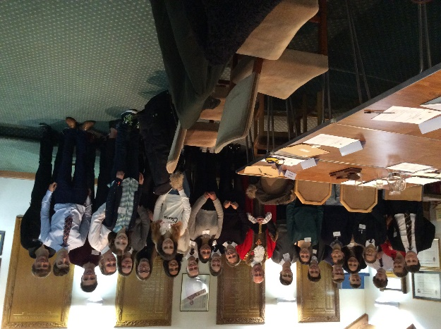
The Youth Councillors have been elected from those living within 5 miles of Sevenoaks Town or attending school within the Town and represent the schools and cadet group below [in alpha order] to cover a diverse range of ethnic backgrounds from a wide area within Sevenoaks to enable engagement for local young people of have their VOICE heard.

- Judd School
- Knole Academy
- Sevenoaks School
- ST John’s CofE Primary School
- St Michael’s Preparatory School
- Tonbridge Grammar School
- Trinity School Sevenoaks
- Tunbridge Wells Girls Grammar
- Tunbridge Wells Grammar School for Boys
- Westerham Sea Cadets

The presence of the Youth Council facilitates Sevenoaks Town Council to be confident that a young person’s point of view will be heard and will assist to progress their ideas. The Town Council is also pleased to form relationships with the local schools.

End

Michèle MacDonald
Committee Clerk
8.11.2018

