**NEWS RELEASE**

**Sevenoaks Youth Councillors visit House of Parliament**

**and have private meeting with Rt. Hon Sir Michael Fallon MP**

On 17th June 2019 the following seven members of Sevenoaks Youth Council visited the House of Parliament for a tour – Ronnie Day, Ola Kujawinska, Sam Crawford, Ishwar Sharma, Gabby Tan, Jacob Watson and Megan Ng. They were accompanied by Cllr Rachel Parry, Chairman of the Youth Services Committee and Linda Larter, Chief Executive from Sevenoaks Town Council.

Sir Michael Fallon said: *“I was delighted to host the Sevenoaks Youth Council in Parliament on Monday 17th June. They were able to have a tour of both Chambers and trace the steps of politicians. The youth councillors posed some good but tough questions and I wish them well in their studies and future careers.”*

The tour was followed by a 45-minute private meeting with Sir Michael Fallon in which a robust question and answer session took place. Below is a precis of the questions asked:

|  |  |  |  |
| --- | --- | --- | --- |
|  | Youth Cllrs | Question | Sir Michael Fallon – response |
| 1 | Sam Crawford | Do you support the proposal for a junction for M26 to A21? | Aware that a new junction whilst helping some local communities has a negative impact on others. Would prefer lorries to use Junction 3, with improved signage. |
| 2 | Ronnie Day | You are on record as voting Remain and against No Deal, so why are you backing Boris? | Nobody wants a no deal, not ideal. Need to prepare in case of a no deal and be able to leave in an orderly way. Boris is not aiming for a No Deal. Practical details need to be addressed. |
| 3 | Jacob Watson | Is it possible to have more transport policies to encourage people to use public transport?  For example, students who remain at schools after 16 not having to pay adult fares. | Transport costs are decided by Kent County Council. He was aware of the pressure on 16+ students and would try to help where possible when budgets were reviewed. |
| 4 | Ola Kujawinska | How will Brexit impact small towns such as Sevenoaks? | Brexit will impact everyone. There has been 40 years of trading relationships with little bureaucracy and paperwork. This will change which could impact goods prices. There may also be an impact on Kent in relation to congestion from ferries.  The UK is a net contributory country some countries are net beneficiaries e.g. Poland. |
| 5 | Gaby Tan | How can more be done to tackle the current environmental crisis and make the UK carbon neutral? | Current initiatives for commitments for carbon neutral are very much welcomed. Need to be aware that some green taxes can place disproportionate burden on those with low incomes. Can also put businesses into unfair competition.  The issue of removing single use plastic must be high on the agenda. |
| 6 | Megan Ng | What are the main challenges now? | Current and potential conflicts creating instability. Attacks on ships in the Gulf as an example. Terrorism. Economic collapse of international trading system. Worldwide political engagement and democracy in retreat. |
| 7 | Ishwar Sharma | I understand that in Croydon some historical churches are being redeveloped into housing and offices, how can they be protected. | There is a system for Listing Buildings. Anyone can do this to protect buildings. |
| 8 | Cllr Rachel Parry | What is the current thinking on the future of social care? | There needs to be a long-term solution for future generations. People are living longer and not saving for old age and future care. The current system sees some not paying for social care in old age and others having to sell their homes. |
| 9 | Jacob Watson | Why did the UK host a visit from President Trump? | The UK have always had a close relationship with the US and had important alliances for example in military and terrorism intelligence. President Trump was elected and represented the US and was invited in that capacity. |
| 10 | Ronnie Day | Do you think the BBC has a left bias? | No, I don’t think so, although some people who work for them might. The Licence Fee needs to be reconsidered – it is an archaic system. It is unlikely that your generation will be viewing tv in the same way as in the past. However, believe it is still important to have a public service broadcasting system which is not governed by advertisers. |

At the end of the meeting Sir Michael Fallon was thanked for his time and there then followed the opportunity for photographs.

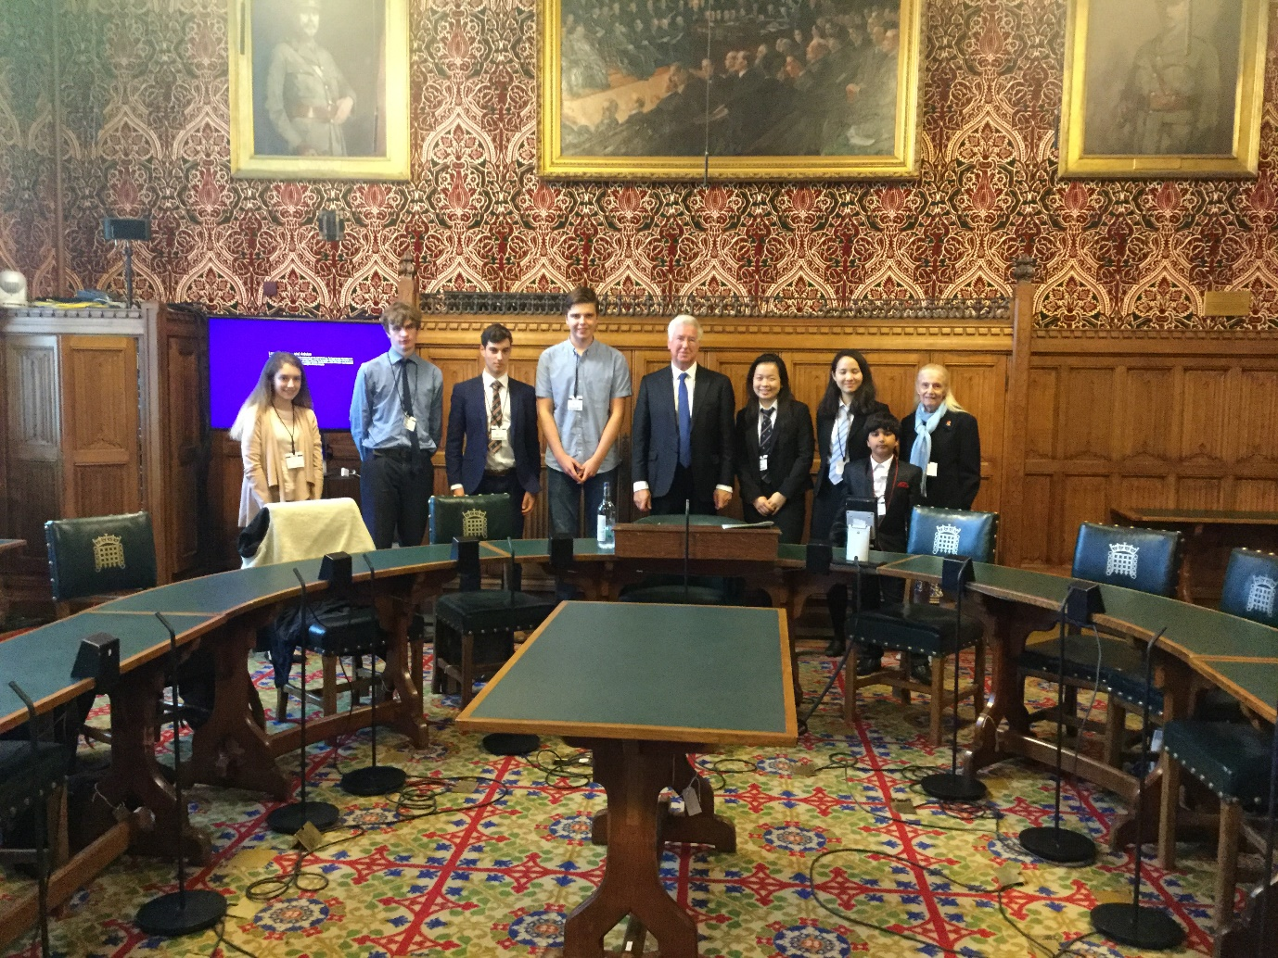

Gabby Tan handing the leaflet on Plastic Free Sevenoaks Pledge to Sir Michael Fallon MP.

Gabby had designed the local and assisted with the wording.

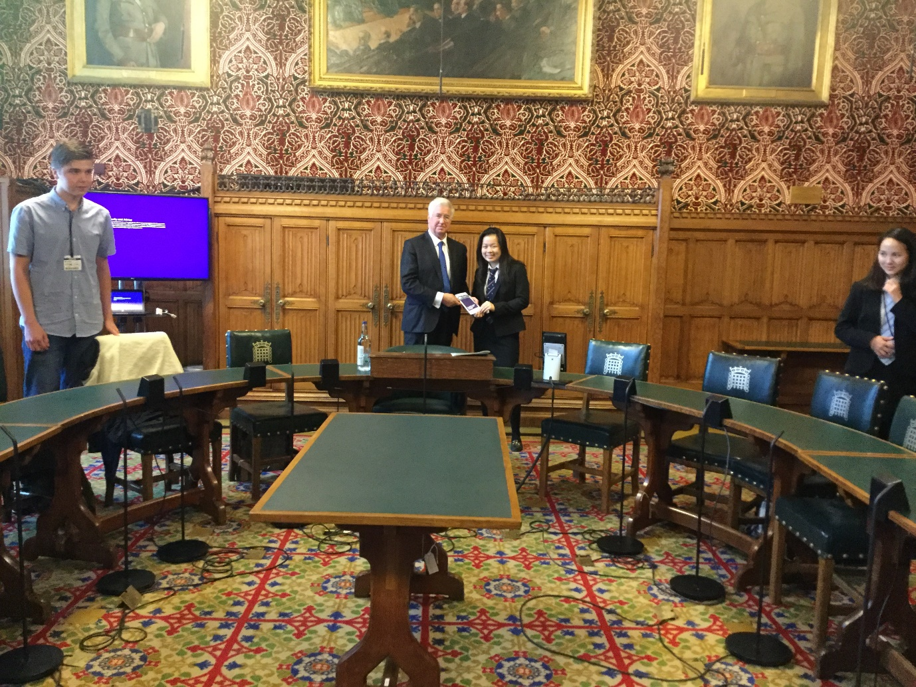

Linda Larter MBE

Chief Executive / Town Clerk

17th June 2019