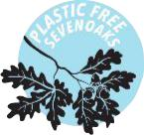

PLASTIC FREE SEVENOAKS PLEDGE

On behalf of __________________ (School), I agree that we will take the following steps to reduce our use of single-use plastic. By doing this, we will play our part in eliminating unsustainable plastic use from Sevenoaks while ensuring a healthier environment.

We, __________________ (School), pledge to do the following:

Separate waste into recyclables and non-recyclables by _________ (date)

Ban / phase out single-use plastic bags by ____________________ (date)

Ban / phase out single-use plastic straws by __________________ (date)

Ban / phase out single-use plastic cups and lids by _____________ (date)

Ban / phase out single-use plates and cutlery by _______________ (date)

Ban / phase out single-use plastic bottles by __________________ (date)

*Please tick the pledge(s) you'd like to undertake and choose a realistic target date. Whether you commit to all or one, every action is a step in the right direction. If your school has already completed an action in the past, please tick the box and provide the date of completion.

Upon achieving your pledges, we will promote your school on our social media platforms and send you a Plastic Free Sevenoaks sticker to display proudly in your school. Please send this completed form and any updates to osl@sevenoakstown.gov.uk

Name

____________

Signature

______________

Date ___________

School _____________________

Email __________________________________________ Contact Number _____________________

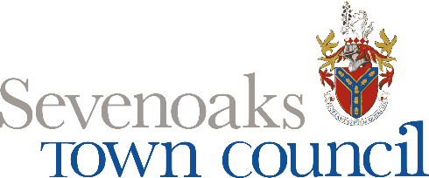 | 